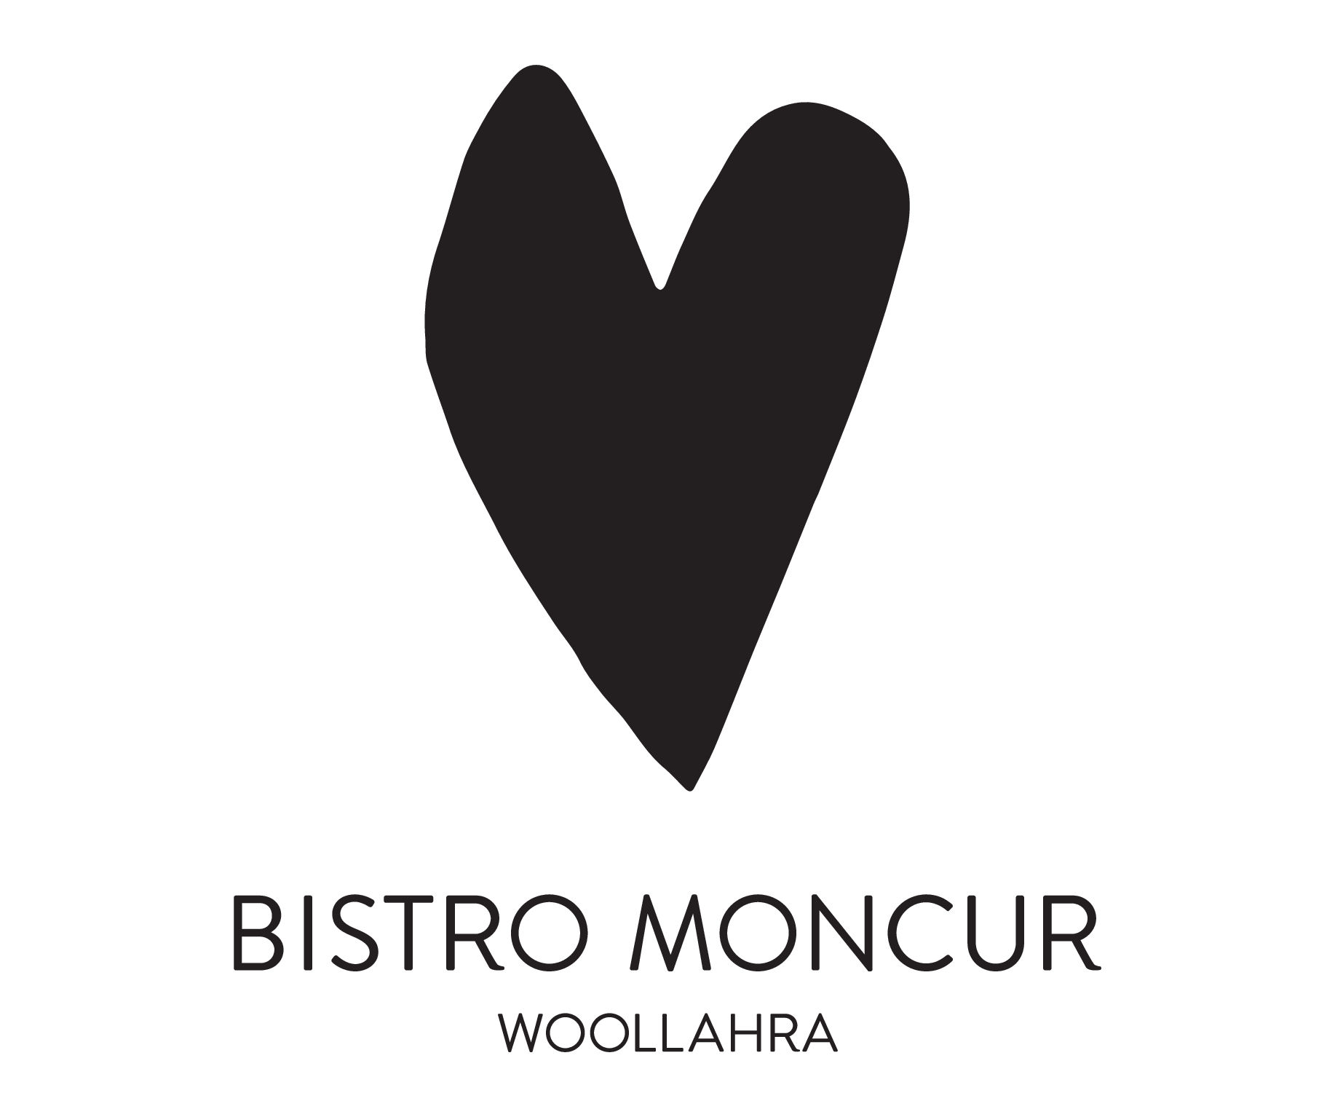
.

entrEe

SYDNEY ROCK OYSTERS, CABERNET SAUVIGNON MIGNONETTE
HALF DOZEN 42 DOZEN 84

CHICKEN LIVER PATE, quince jam, CORNICHONS & BRIOCHE 29

heirloom tomato salad, marinated olives and basil 28

o’connor STEAK TARTARE
parmesan, egg yolk, rocket salad and pommes allumettes 35 / 56

SALAD OF BABY GEM
CAPERS, ROQUEFORT, SLOW COOKED EGG, CROUTONS 27

TUNA TARTARE
CAPERS, CUCUMBER, RADISH, GREEN CHILLI, PUFFED RICE 34 / 56

FRENCH ONION SOUFFLE GRATIN 31

pea & ricotta agnolotti
preserved lemon, crispy pancetta, oregano beurre noisette 32 / 52

Ora King salmon & Beetroot Gravlax (NZ)
capers, horseradish creme fraiche and toasted sourdough 34 / 56

shark island Spanner crab omelette, roasted garlic & espelette beurre noisette 43

MAIN course

TROTTOLE PASTA
ASPARAGUS, BROAD BEANS, CAVOLO nero, STRACCIATELLA, CHILLI AND GARLIC OIL 44

STEAMED BLUE-EYE TREVALLA (NZ)
LEEK FONDUE, DUTCH CARROTS, CHAMPAGNE, CAPER & DILL BEURRE BLANC 57

PAN-ROASTED daintree BARRAMUNDI
ZUCCHINI, VONGOLE, CONFIT FENNEL & TOMATO, PISTACHIO PISTOU 52

SPATCHCOCK PERSILLADE
SPRING GREENS, GARLIC, PARSLEY, LEMON THYME JUS 55

KINROSS LAMB RUMP
POMMES PUREE, GLAZED ONION, SALSA VERDE 58

GRILLED rangers valley SIRLOIN MB3+, CAFE DE PARIS, fries 67

o’connor FILLET STEAK MB3+, SAUCE BEARNAISE, fries 69

o’connor MINUTE STEAK MB3+, WINE MERCHANT’S SAUCE, fries 57

1 KG O’CONNOR T-BONE MBS3+ (VIC), FRIES AND CHOICE OF SAUCE 199 to share

SIDES

MARKET VEGETABLE 15
BROCCOLI & ALMONDS 16
leaf SALAD 14
FRIES 15

DESSERT

bistro moncur house made ice creams and sorbets 7 each

passionfruit souffle, salted coconut ice cream 26
2022 DOMAINE PICHOT LE MARIGNY, VOUVRAY MOELLEUX, LOIRE VALLEY FRANCE 18

vanilla creme BRULEE WITH LEMON THINS 24
NV RIESLINGFREAK No.7 FORTIFIED RIESLING, CLARE VALLEY SA 16

mango & lime trifle
lime crEme diplomat, coconut daquoise, mango sorbet, coconut tuille 24
2020 château audinet, SAUTERNES, BORDEAUX, FRANCE 22

black forest bombe alaska
cherry sorbet, stracciatella ice cream, chocolate sponge 24
2020 château audinet, SAUTERNES, BORDEAUX, FRANCE 22

pistachio & RasPberry delice, mesSina jersey milk sorbet 24
2022 DOMAINE PICHOT LE MARIGNY, VOUVRAY MOELLEUX, LOIRE VALLEY FRANCE 18

double chocolate profiteroles
Chocolate creme diplomat, Chocolate Sauce, Cocoa Nib 21
lusta PEDRO XIMENEZ SHERRY, spain 14
our pastry chef’s Petits fours 35

madeleines & lemon curd 10
2022 DOMAINE DES BERNADINS, MUSCAT BEAUMES DE VENISE, RHONE VALLEY, FRANCE 18

a selection of european & australian cheeses, house made lavosh and preserves 11 each
FONSECA WATERLOO EDITION RESERVE PORT 18 / 190

after dinner
LUSTAU pedro ximenez (60mls) 14
strega limoncello (45mls) 10
amaro montenegro (45mls) 12
FIVE FARMS IRISH CREAM LIQUEUR (60 ML) 14
mery melrose VS COGNAC 13
Tesseron xo grande champagne cognac 48
delord vsop Bas armagnac 15
DELORD 1996 BAS ARMAGNAC 21
DELORD 1966 BAS ARMAGNAC 36

VITTORIA CINQUE STELLE COFFEE 6
lA mAISON DU tHe 6
eNGLISH BREAKFAST / EARL GREY
penelope sachs herbal infusions 6
pETAL - lemongrass, lavender, red clover, rosehips, rose petals & chamomile
apres - chamomile, peppermint, spearmint, aniseed & fennel
TRIPLE E – LIQUORICE ROOT, FENNEL & PEPPERMINT
Lemon tang- lemongrass & mint
peppermint
green tea

